**INDIA’S AGRICULTURAL CROP PRODUCTION ANALYSIS**

**(1997-2021)**

**1.INTRODUCTION:**

**1.1 Overview:**

First I created an EMPATHY MAP. The map has four Quadrants -Says, Things, Does and Feels. What are the difficulties face farmers to get the yield. And also I included some steps and methods to increase the yield. Next, I created the BRAINSTORM. Here me and my team members discuss about hoe the crops faced problems due to insects and give the solutions about how to get good yield. Our problem statement is “Why farmers not get good yield in crop production”. Next I created the data Analysis-Dashboard and story. After I published my dashboard & story in tableau public.

**1.2 Purpose:**

Practically all agricultural production is reliant on natural conditions such as climate, soil, pests, and weather. With the help of data analysis for agriculture businesses, farmers can observe the impact that extreme weather conditions and other phenomena can have on their crops.

**2. PROBLEM DEFINITION & DESIGN THINKING:**

**2.1 Empathy map:**

An empathy map is a collaborative tool teams can

use to gain a deeper insight into their customers. Much like a user persona, an empathy map can represent a group of users, such as a customer segment. The empathy map was originally created by Dave Gray and has gas gained much popularity with in the agile community.

An empathy map is a tool used in design thinking to build an emotional Representation of a user or the customer. It is versatile activity that may be used to generate new product ideas as well as better understand existing ones. 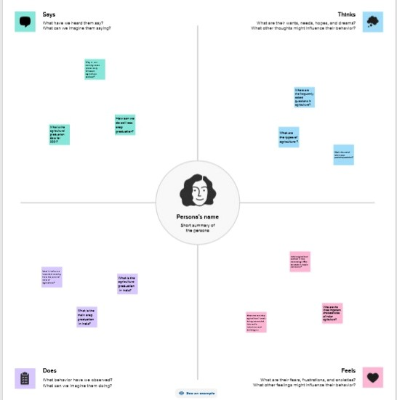

**BRAIN STORM:**

Brainstorming is a group problem-solving method that involves the spontaneous contribution of creative ideas and solutions. This technique requires intensive, freewheeling discussion in which every member of the group is encouraged to think aloud and suggest as many ideas as possible based on their diverse knowledge.

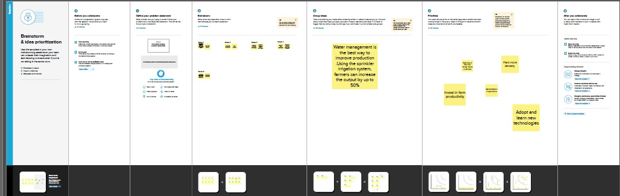

**RESULT: DASHBOARD**

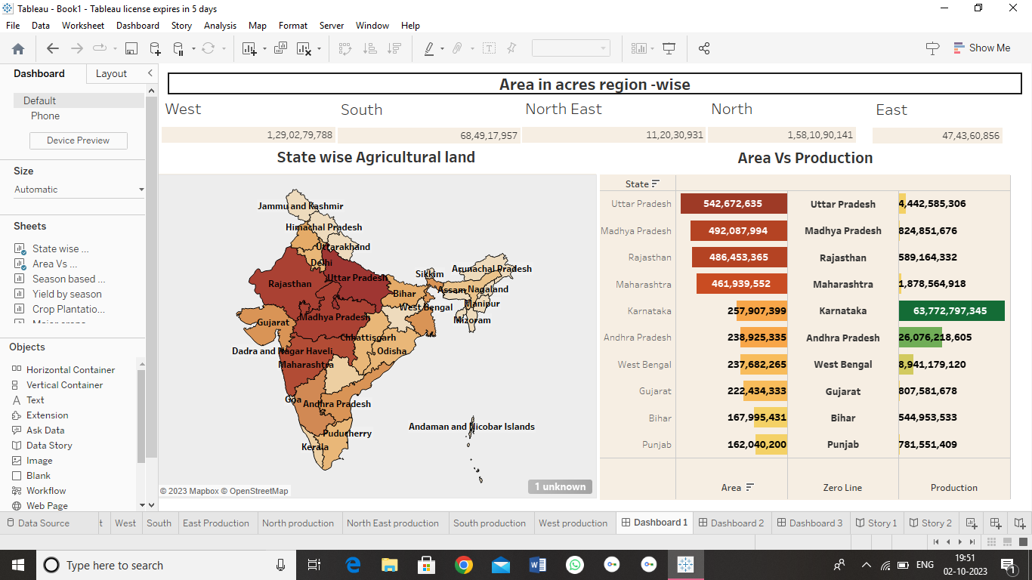

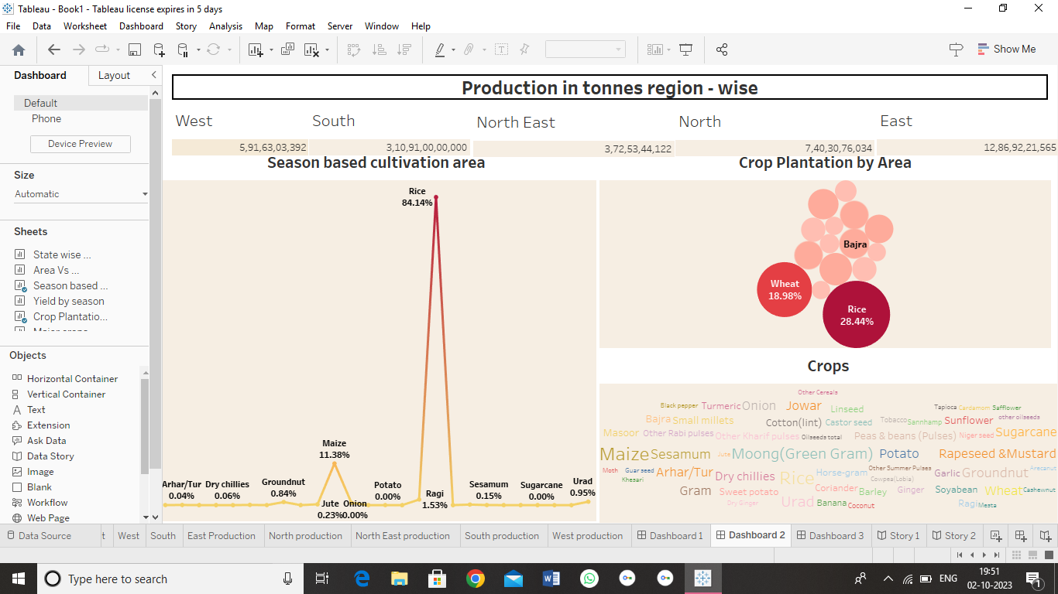

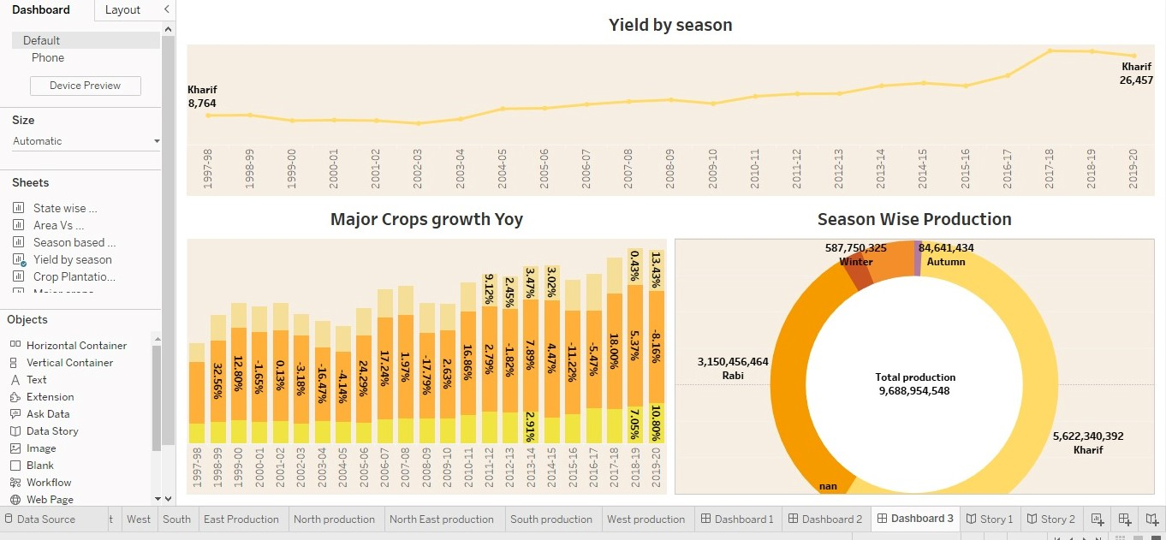

**STORY**

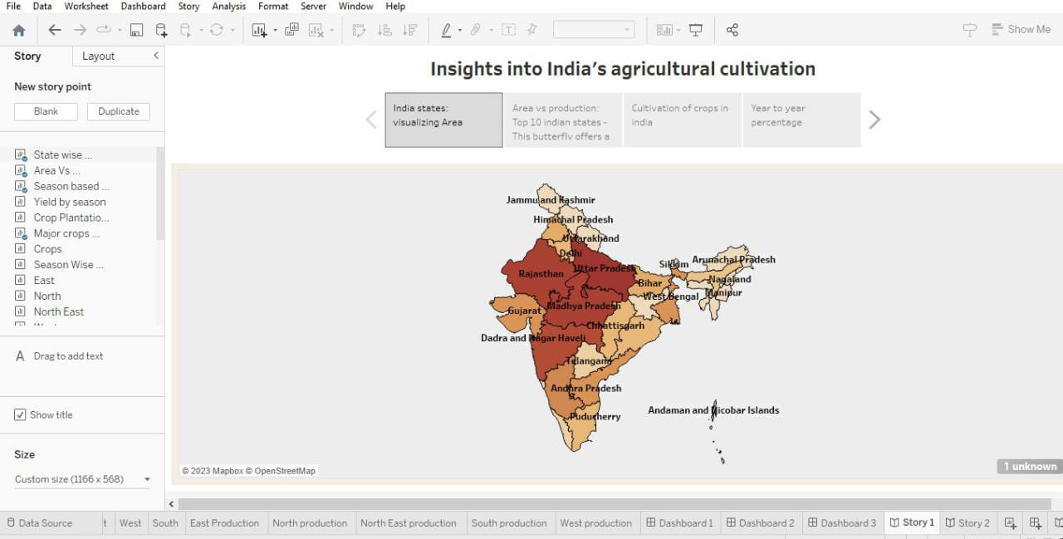

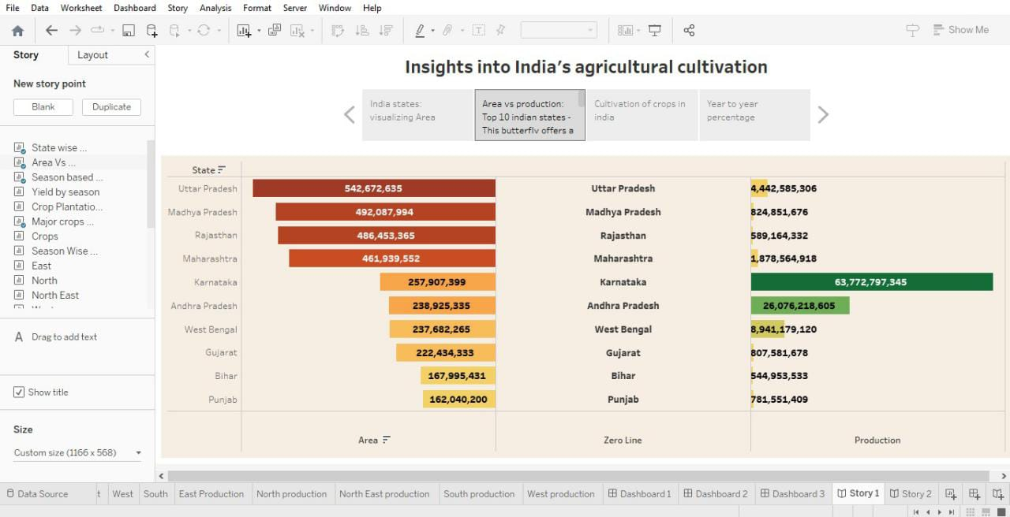

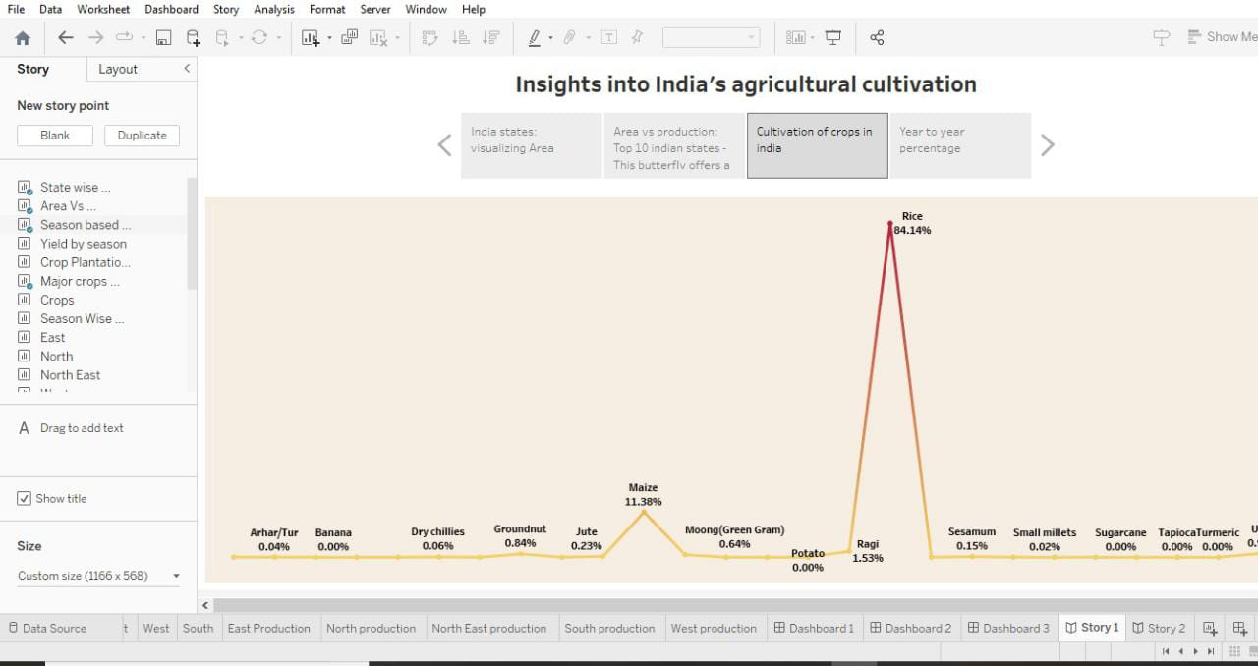

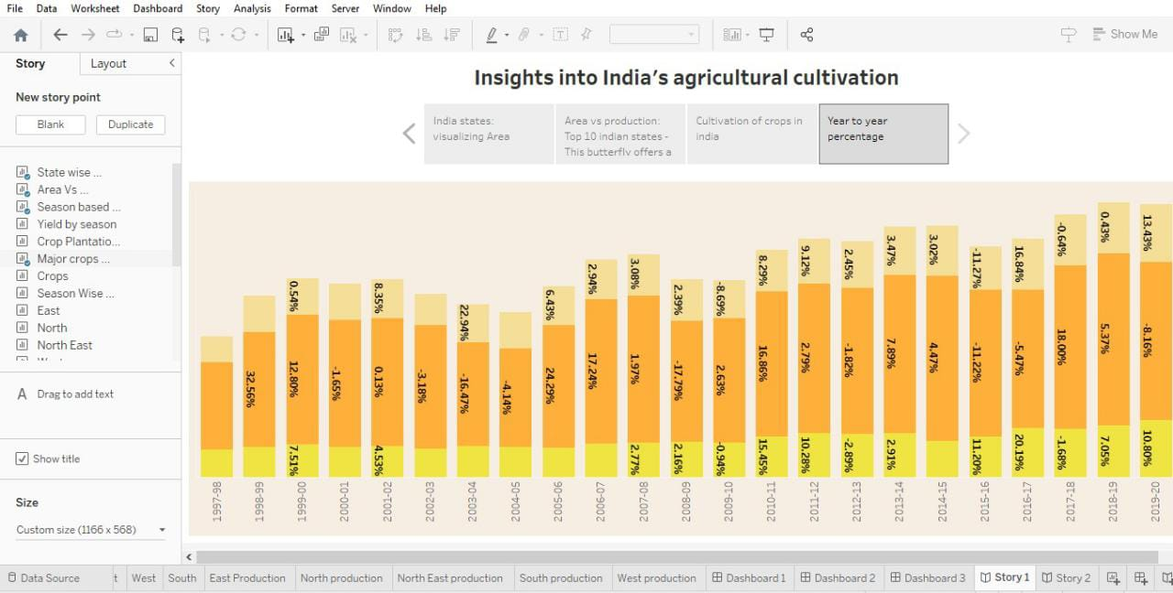

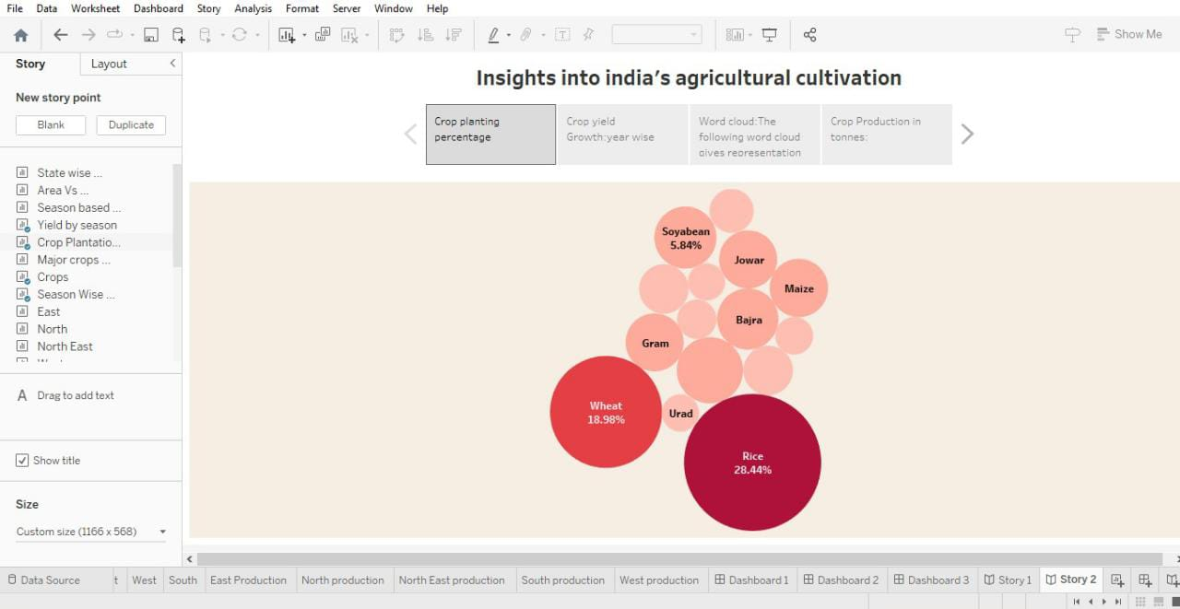

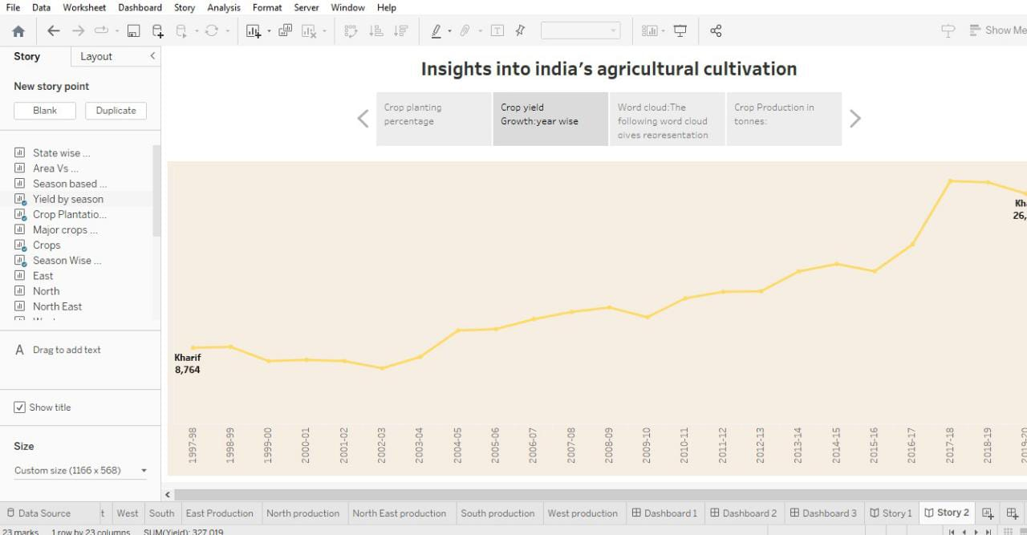

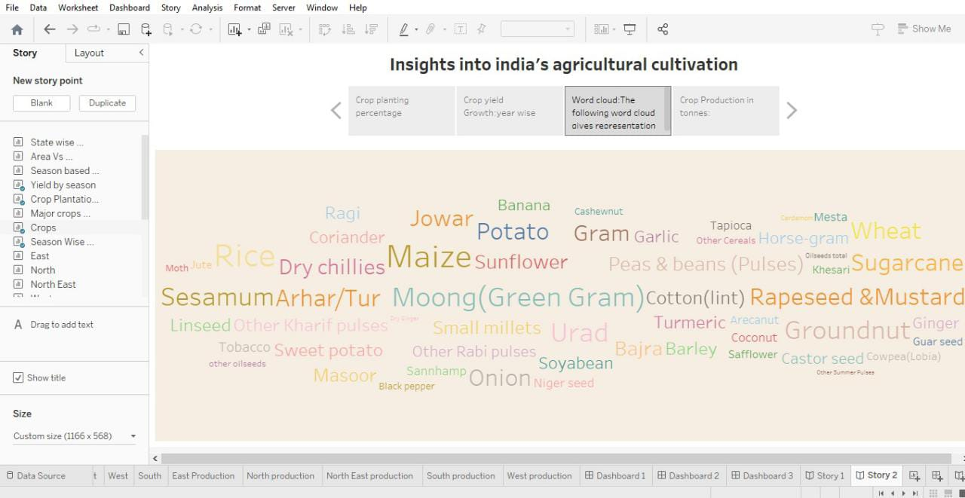

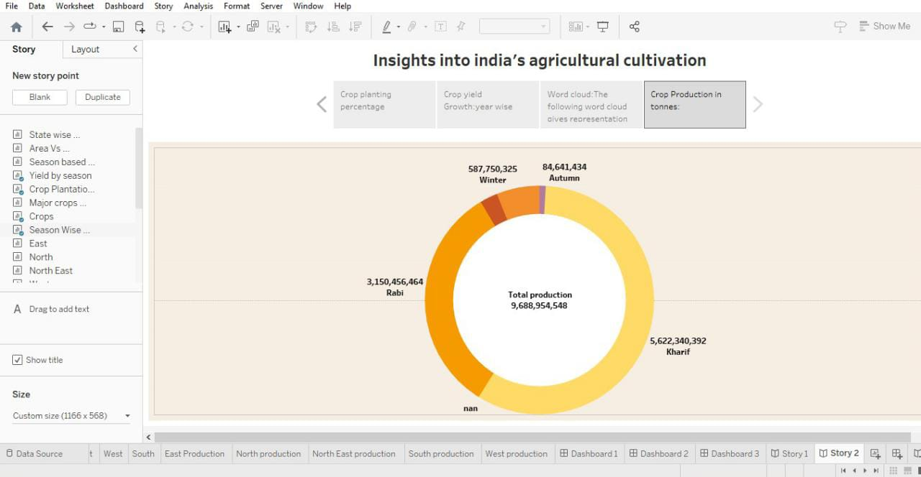

**4. ADVANTAGES & DISADVANTAGES**

**ADVANTAGES:**

* Agriculture supplies raw materials to various agro-based industries like sugar, jute, cotton textile and vanaspati industries. Food processing industries are similarly dependent on agriculture. Therefore the development of these industries entirely is dependent on agriculture.
* Agriculture impacts society in many ways, including: supporting livelihoods through food, habitat, and jobs; providing raw materials for food and other products; and building strong economies through trade
* Agriculture refers to the science, art, and the business of growing food and raising livestock for profit and the activities include poultry, livestock and fisheries. Agriculture is a significant part of the Indian economy, accounting for over 17% of total GDP and employing more than 60% of the population.

**DISADVANTAGES:**

* There is no diversification of farm produce. Crops may be attacked by pests and disease's. Farmers have only one source of income. Weather and climate may affect crop productivity.
* Erosion of soil by heavy rain, floods, insufficient vegetation cover etc., reduces farm productivity. Inadequate irrigation facilities and poor management of water resources have led to a great decline in agricultural productivity.

**APPLICATIONS:**

Agriculture technology or Agri technology is also known as agritech. It is efficient in mapping, monitoring, and managing farming decisions precisely. Agriculture solutions come in various formats such as satellite imagery, sensors, agriculture machines, and software solutions

Implementing these technological solutions enable reliable management and monitoring of farms. As farmers get a complete digital analysis of farms in real-time, they can act accordingly and don’t have to apply excess pesticides, fertilizers and reduce overall water consumption.

**CONCLUSION:**

The Indian economy is an agro-economy and depends highly on the agricultural sector. Despite just supporting the Indian Economy, the agricultural sector also supports the industrial sector and international trade in imports and exports.

**FUTURE SCOPE:**

* **On over all view , India has always been benified by AGRICULTURE.**
* **Though the future of India is industrialization , the contribution of agriculture would always prove to be vital for making India a powerful and stable economy in the future.**